Question no 6

Code:

Main.py:
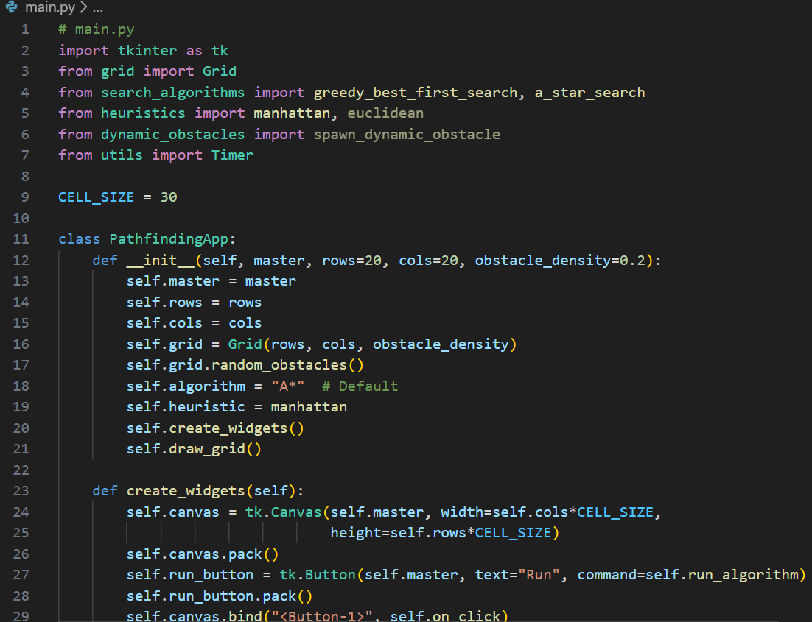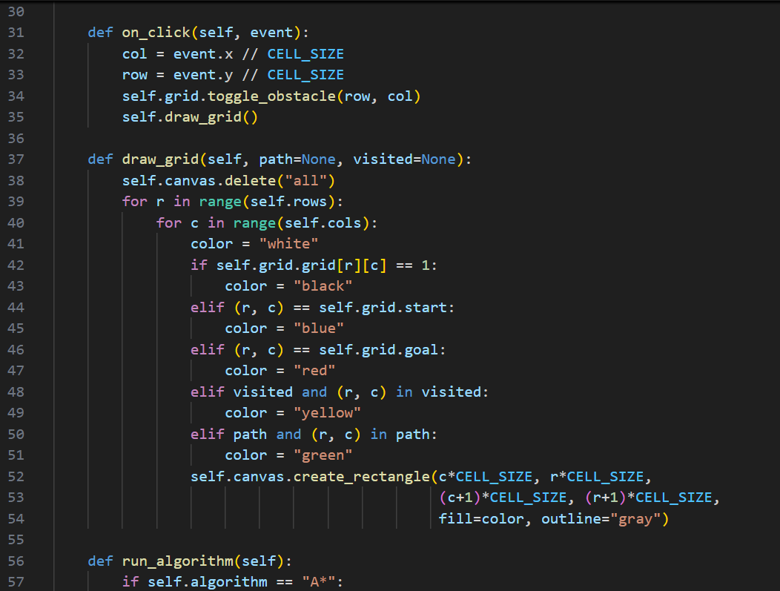

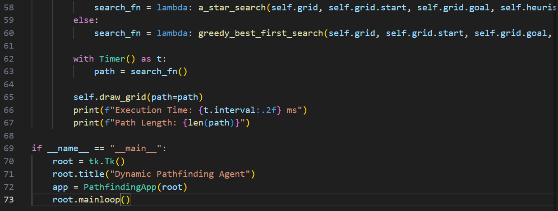
Search_algorithms.py:
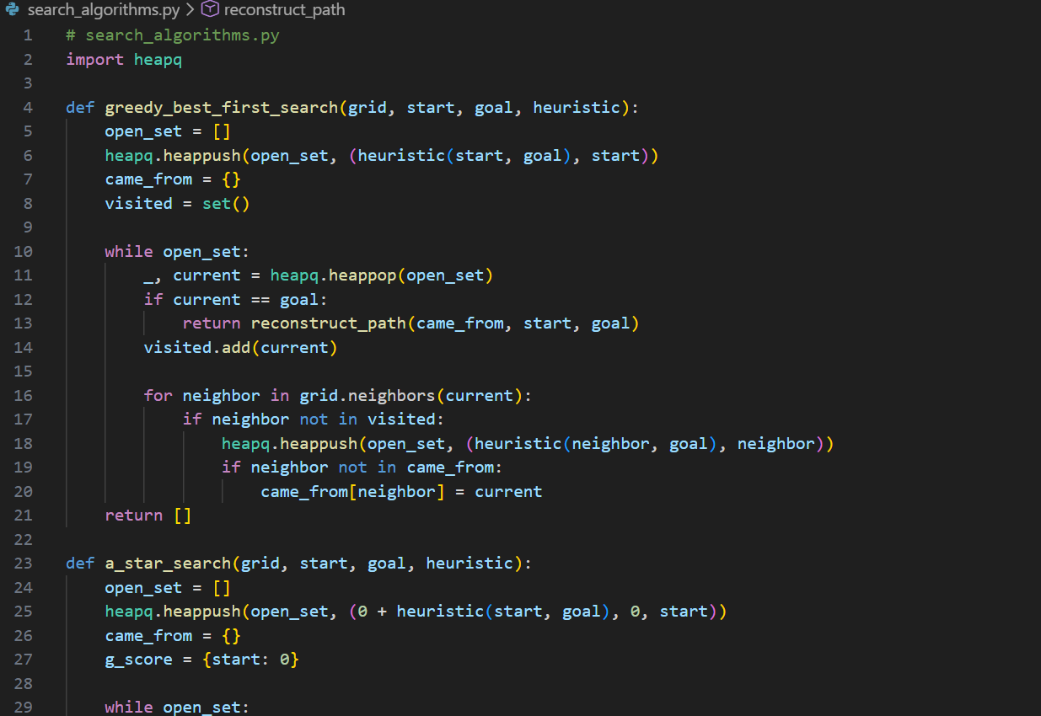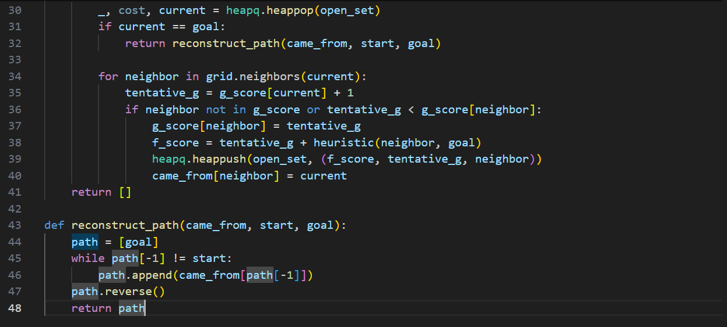

Heuristic.py:
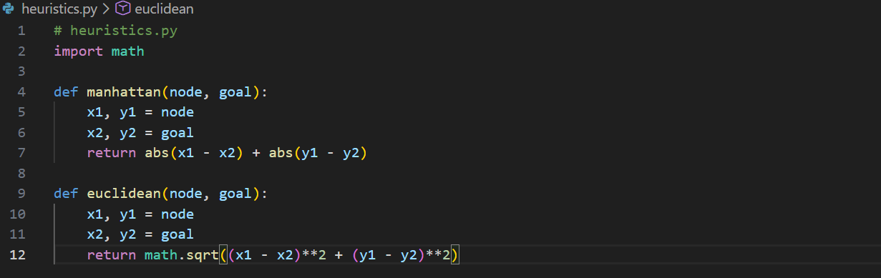

Grid.py:
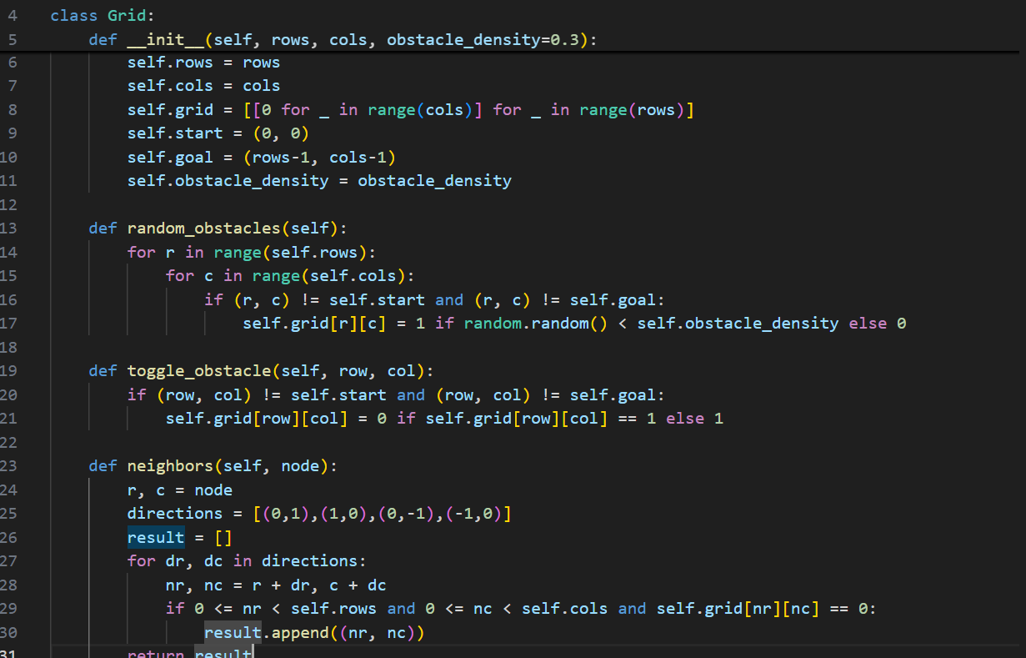

Dynamic_obstacles.py:
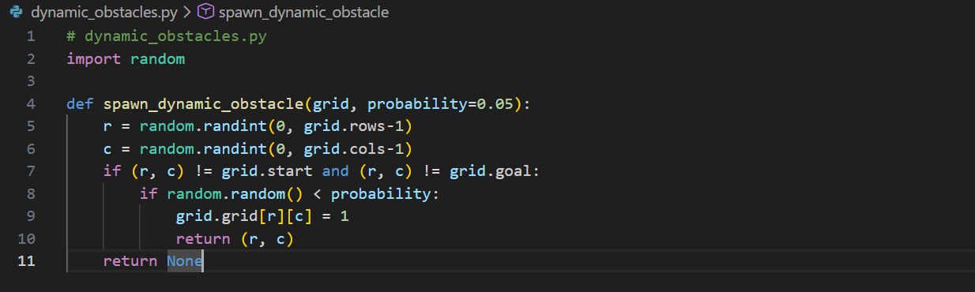

Utils.py:
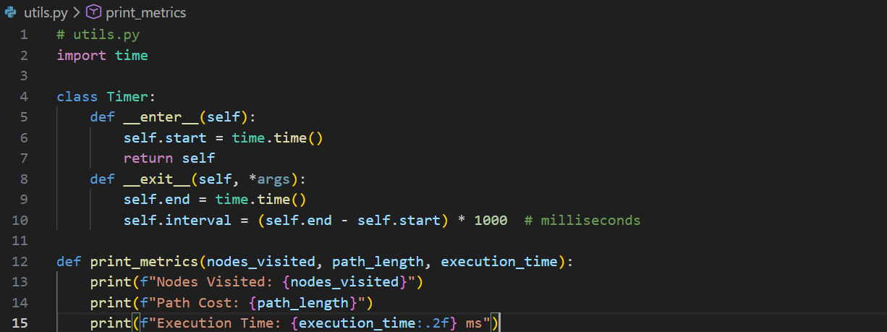

Output:
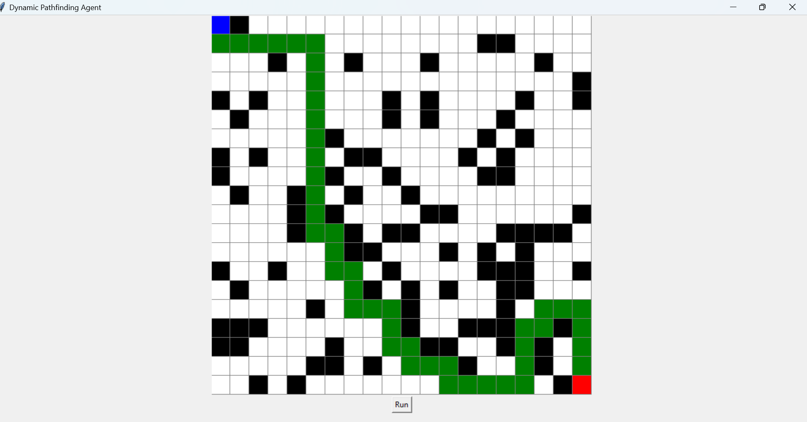
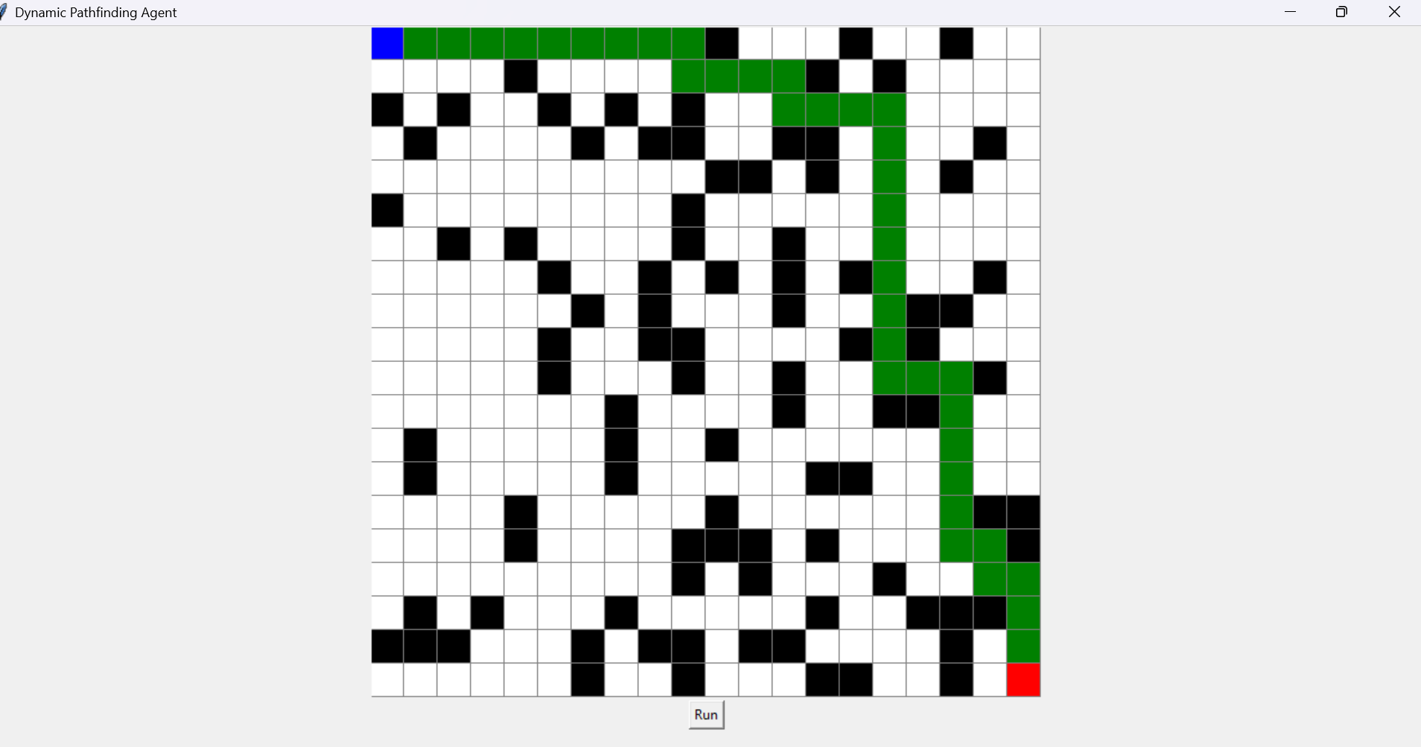
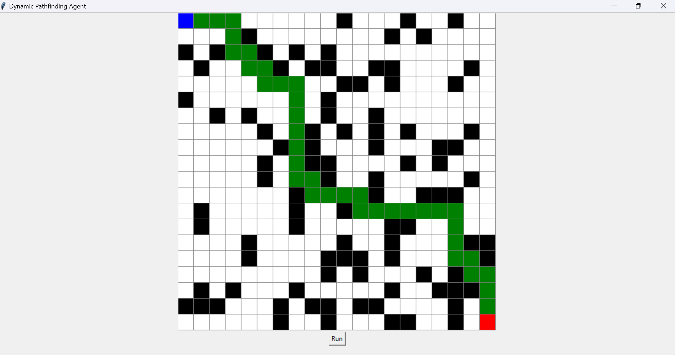
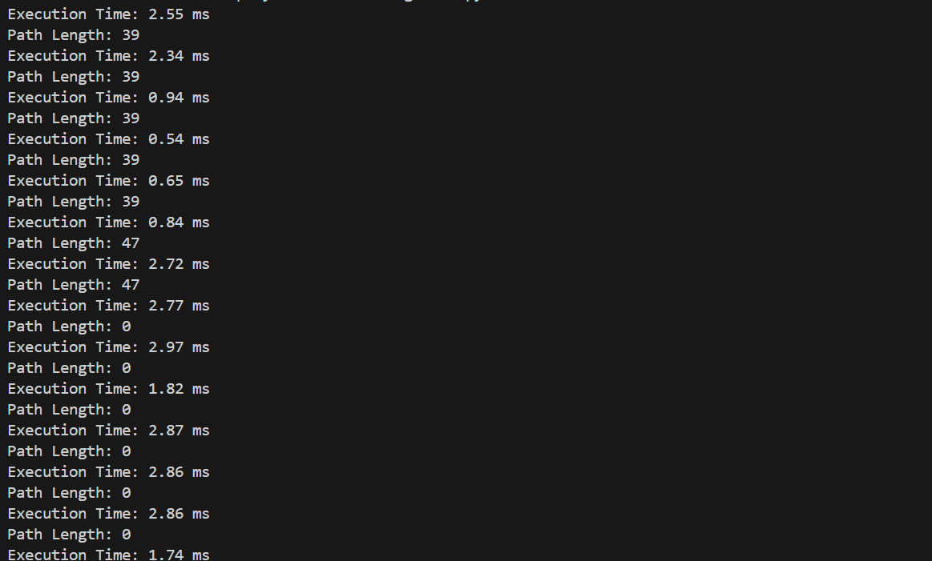

Description:

Dynamic Pathfinding Agent – Point-wise Description

Project Overview
- Navigate a grid from Start to Goal using Greedy Best-First Search (GBFS) or A*.
- Handles dynamic obstacles appearing while the agent moves.
- GUI shows real-time pathfinding visualization and metrics.
- Users can edit the grid and select heuristics.

File Descriptions
1. main.py
- Entry point of the program.
- Initializes grid and GUI.
- Let’s users select algorithm (GBFS/A*) and heuristic.
- Starts search and updates the visualization in real-time.
- Handles dynamic obstacles and triggers re-planning if needed.
2. search_algorithms.py
- Implements GBFS (f(n) = h(n)) and A* (f(n) = g(n) + h(n)).
- Expands nodes using a priority queue.
- Tracks visited nodes to avoid loops.
- Supports re-planning if path is blocked by obstacles.
3. heuristics.py
- Contains heuristic functions for search:
  - Manhattan Distance – sum of horizontal and vertical distances.
  - Euclidean Distance – straight-line distance.
- Helps GBFS/A* decide which node to explore next.
4. grid.py
- Creates and manages the grid environment.
- Each cell stores info: position, obstacle status, costs.
- Supports random obstacle generation and manual placement/removal.
- Provides neighbour nodes for pathfinding.
5. dynamic_obstacles.py
- Adds obstacles dynamically while agent moves.
- Probability-based obstacle spawning each step.
- Detects if current path is blocked.
- Triggers efficient re-planning without restarting the search.
6. utils.py
- Utility functions for timing, metrics, and visualization.
- Calculates path cost, nodes visited, execution time.
- Updates GUI metrics in real-time.
7. README.md
- Explains installation and usage.
- How to run main.py, select algorithm/heuristic, and edit the grid.
- Lists dependencies: e.g., pip install pygame.
8. report.pdf
- Explains project objectives and implementation details.
- Compares GBFS vs A* with pros and cons.
- Shows best-case and worst-case scenarios with screenshots.
- Includes metrics: nodes visited, path cost, execution time.

Project Workflow (Simplified)
- Launch main.py → set grid size, algorithm, heuristic.
- Grid is initialized; obstacles are placed randomly or manually.
- Agent searches path using GBFS or A*.
- Heuristics guide node selection.
- Dynamic obstacles appear if enabled.
- Agent detects blocked path → re-plans from current position.
- GUI shows frontier nodes (yellow), visited nodes (red/blue), final path (green).
- Metrics like path cost, nodes visited, execution time are displayed.

